**RED WATER 2013 SURVEY**

1. **GOALS**

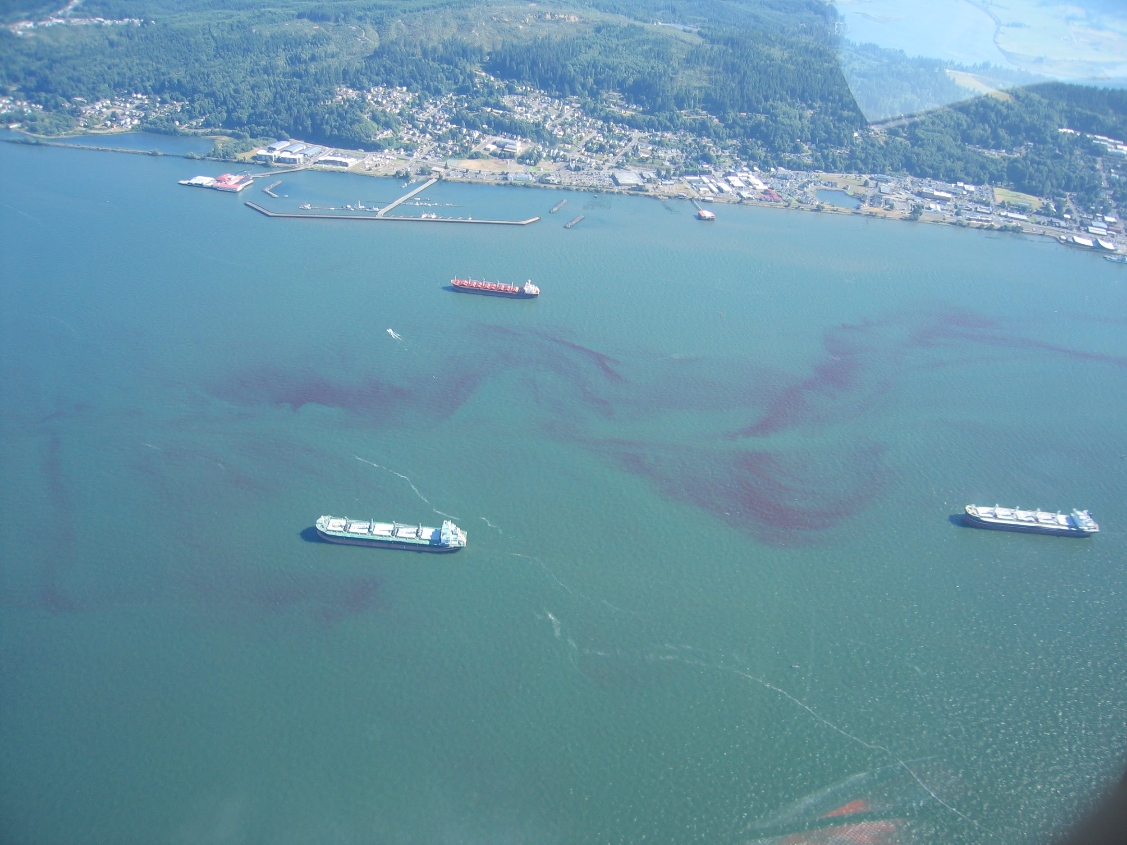

**The overall goal of the proposed survey is to examine the biological and physical interactions that drive the dynamics of *Myrionecta rubra* in the Columbia River estuary. We will 1) evaluate the influence of cryptophyte population on the temporal evolution of *M. rubra* bloom and 2) estimate the role of physical processes in shaping pattern of *M. rubra* spatial distribution in the South Channel of the estuary.**

We will try to address more specifically the following questions:

*- Do a change in cryptophyte division rates influence the biomass of M. rubra?*

*- During what part of the tidal cycle does M. rubra feed on cryptophyte?*

*- Do patches of red water occur in the same areas over multiple days, and if so, how do they*

*maintain their position?*

*- Do fronts determine the location of M. rubra?*

*- During what part of the tidal cycle does the red water appear in surface water?*

We will combine high-temporal resolution observation of abundances, division and net loss rates (mortality + advection) for cryptophyte populations at the Saturn 03 observation network using a continuous flow cytometer (SeaFlow). A previously developed size-structured population matrix model will be used to estimate *in situ* hourly division and loss rates of cryptophyte populations. SeaFlow-based continuous measurements of cell size have been successfully used to estimate division rates of cryptophyte population in culture. Loss rates (cell mortality + advection) are derived from cell abundance measures, given the estimated division rates.  *M. rubra* cell abundances will be measured once a day during slack period in surface waters to help interpreting pattern of loss rates. Cryptophyte species diversity will be evaluate once a week to help interpreting pattern of division rates of the cryptophyte population.

The data collected by the aircraft will provide great spatial resolution of *M. rubra*, while data collected by the SeaFlow will give the necessary temporal resolution to characterize the dynamics of crytophyte populations at SATURN03. Combined with physical and biological models, these data have a great potential for shedding new light into the biological and physical interactions that drive the spatial and temporal evolution of red waters in the Columbia River estuary.

1. **SAMPLING PLAN**
   1. **SATURN03**

Located on a pier near Hammond, OR. Water from the South Channel is pumped from three depths (2.4 m, 8.2 m and 13 m depth) through a series of sensors housed in a building on the pier. Sensor descriptions and data access are available at:<http://www.stccmop.org/datamart/observation_network/fixedstation?id=saturn03>

* We will measure continuously in surface water (2.4 m) cell abundances and size of < 20 micron phytoplankton, bulk red and orange fluorescence, O2 and nitrate concentration as well as temperature, salinity and light intensity.
* We will also collect discrete samples once a day around the slack period after high tide. We will collect 1) samples for flow cytometry analysis at the three depths to further characterize cryptophyte population, 2) samples in surface for FlowCAM and microscopy analysis to quantify M. rubra abundance and 3) samples in surface for nutrient analysis.
* We will also collect once a week samples in surface for DNA analysis to evaluate cryptophyte diversity
  1. **AIRCRAFT**

coming soon...

1. **ANALYSIS PLAN**

The coarse data analysis will be done by early december. This include: cell counts of cryptophyte populations (Armbrust) and M. rubra (Peterson), bulk red and orange fluorescence, O2 and nitrate concentration, temperature, salinity and light intensity (Riseman), nutrients (Needoba) and cryptophyte diversity (Zuber), concatenated images of red water in the South Channel (Chickadel).

Hourly estimates of division and loss rates will be available by early February.

All data will be archived and made available on CMOP website.

1. **PARTICIPANTS**

Virginia Armbrust - [armbrsut@uw.edu](mailto:armbrsut@uw.edu)

Antonio Batista - [baptista@stccmop.org](mailto:baptista@stccmop.org)

Chris Chickadel - [chickadel@apl.washington.edu](mailto:chickadel@apl.washington.edu)

Gordon Farquharson - [gordon@apl.washington.edu](mailto:gordon@apl.washington.edu)

Lydie Herfort - [herfortl@ebs.ogi.edu](mailto:herfortl@ebs.ogi.edu)

Pete Khan - [pkahn@stccmop.org](mailto:pkahn@stccmop.org)

Clara Llebot - [llebot@stccmop.org](mailto:llebot@stccmop.org)

Craig McNeil - [cmcneil@apl.washington.edu](mailto:cmcneil@apl.washington.edu)

Joe Needoba - [needobaj@ebs.ogi.edu](mailto:needobaj@ebs.ogi.edu)

Tawnya Peterson - [petersont@stccmop.org](mailto:petersont@stccmop.org)

Francois Ribalet - [ribalet@uw.edu](mailto:ribalet@uw.edu)

Sarah Riseman - [riseman@ohsu.edu](mailto:riseman@ohsu.edu)

Jarred Swalwell - [jarred@uw.edu](mailto:jarred@uw.edu)

Holly Simon - [simonh@ebs.ogi.edu](mailto:simonh@ebs.ogi.edu)

Yvette Spitz - [yvette@coas.oregonstate.edu](mailto:-yvette@coas.oregonstate.edu)

Ian Voorhees - [ian.voorhees@gmail.com](mailto:ian.voorhees@gmail.com)

Michael Wilkin - [wilkin@stccmop.org](mailto:wilkin@stccmop.org)

Peter Zuber - [pzuber@ebs.ogi.edu](mailto:pzuber@ebs.ogi.edu)